Data Audit Report
Prepared by
Lead Data Science Team

Analysis provided for
Fortune Corp

Requested by
SVP of Human Resources

June 1, 2018

Introduction

Fortune Corp, a maker of specialized laboratory equipment for the pharmaceutical industry, began business in June 1980. Priding itself on employee job satisfaction, the company is seeking to understand why employees voluntarily leave the company.

Over the last 3 years, at the request of the SVP of Human Resources, the HR department has been conducting an employee survey. The SVP wants enough data collected so that a predictive model of employee voluntary attrition can be built and tested. The objective is to use such a model to find current employees who might be thinking of leaving, so proactive steps can be taken to retain them.

The SVP now thinks there has been enough data collected. So, she has requested that the lead data science team take over and perform a data audit.

The qualifications for the target sample are having taken the survey. This sample is broken into two segments:
- Employees who voluntarily left the company
- Employees who are still with the company

The following 5 data files have been created for your use by the IT department:
- (csv) Credit Bureau file: fortune_credit.csv
  - FICO score (SVP thinks this might be predictive)
- (SAS) Accounting file: fortune_acct
  - Payroll data
- (SAS) Attrition file: fortune_attrition
  - Employees who have left the company over the 2015-2017 period.
- (SAS) HR file fortune_hr
  - Background employee data
- (SAS) Survey file fortune_survey
  - Data collected from the employee survey.

The purpose of this data audit is to ensure the following:
- The lead data science team has received all the data files intended for this project.
- The lead data science team understands the content, layout, and format of these files.
- The data in these files are of sufficient integrity and quantity to support the model development.

This data audit consists of 5 sections:

Datafile Summary: A list and description of all data files received.

Datafile Detail: For each datafile, tables showing all data fields received, their values, summary statistics, and distributions. Data fields are categorized into one of 4 types of analytical variables:

Categorical - data fields with distinct levels or values which represent categories; can be a number or a label, nominal or ordinal.

Date - data fields that are identified as calendar dates.

Numeric - data fields that are continuous numeric data.

Character - data fields whose values are characters and are not otherwise classified as categorical.

Modeling Sample – After merging all supplied datafiles, a determination is made as to whether there is adequate sample size for each target sample to support model development.

Questions – The auditing process will uncover data integrity issues. This section lists what the lead data science team has found in this regard. This section also poses specific questions on data field definitions, field coding, and interpretation, answers to which will facilitate the team’s model development effort.

Datafile Summary

The lead data science team has received 5 data files from SVP of Human Resources as listed in Table 1.

Table 1. Datafiles Received
Filename | File Type | # Of Records | File Contents
fortune_credit | CSV | 4,867 | Social Security Number, FICO Score
fortune_acct | SAS | 4,867 | Daily Rate, Department, Hourly Rate, Monthly Income, Overtime, Percent Salary Hike, Performance Rating, Stock Option Level, Employee Number, Social Security Number
fortune_attrition | SAS | 262 | Employee Number, Departure Date
fortune_hr | SAS | 4,867 | Education, Education Field, Gender, Birth Date, Birth State, Employee Number, First Name, Hire Date
fortune_survey | SAS | 1,470 | Business Travel, Distance From Home, Environment Satisfaction, Job Involvement, Job Level, Job Satisfaction, Marital Status, Number Of Companies Worked, Relationship Satisfaction, Total Working Years, Training Times Last Year, Work Life Balance, Years In Current Role, Years Since Last Promotion, Years With Current Manager, Employee Number

Datafile Detail
Each datafile contains the analytic data fields as shown in the following tables. Note that the data fields have been classified based on their potential analytical usage.

Datafile #1: fortune_credit
File Analytic Contents:
Numeric Fields (1): fico_scr
Categorical Fields (1): ssn
Character Fields (0):
Date Fields (0):
Records: 4,867
Columns: 2
Notes: The numeric categorical data field ssn appears to be a likely row id or index field, so it will be evaluated as Character Data.

Table 1.1 fortune_credit - Numeric Data
Analytic numeric data fields
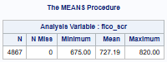 | 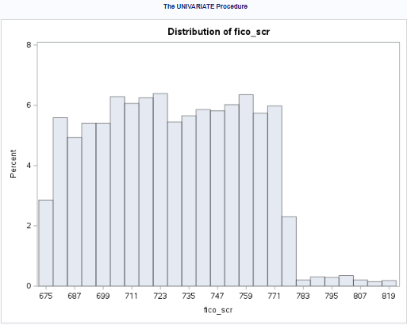
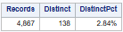

Table 1.3 fortune_credit - Character Data
Analytic character data fields
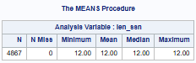 | 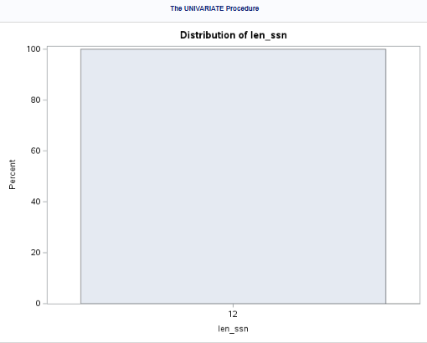
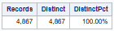

Datafile #2: fortune_acct
File Analytic Contents:
Numeric Fields (4): DailyRate, HourlyRate, MonthlyIncome, PercentSalaryHike
Categorical Fields (6): Department, OverTime, PerformanceRating,
StockOptionLevel, employee_no, ssn
Character Fields (0):
Date Fields (0):
Records: 4,867
Columns: 10
Notes: The numeric categorical data field employee_no and the character categorical data field ssn could be a row id or index field, so they will be evaluated as Character Data.

Table 2.1 fortune_acct - Numeric Data
Analytic numeric data fields
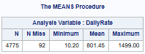 | 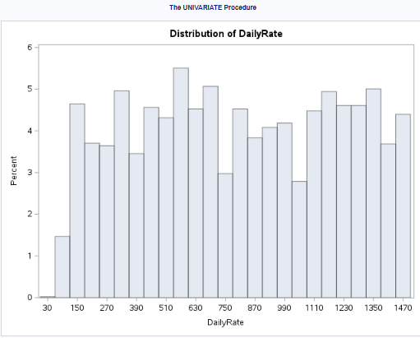
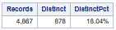
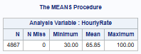 | 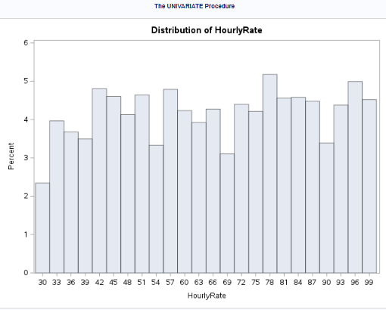
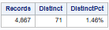
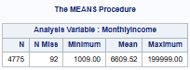 | 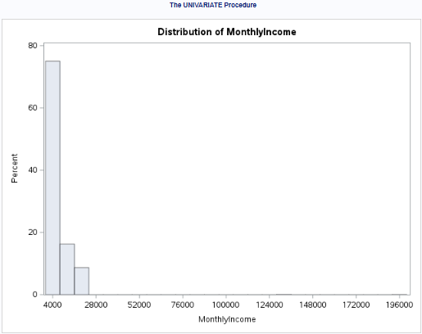
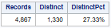

Table 2.1(cont.) fortune_acct - Numeric Data
Analytic numeric data fields
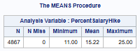 | 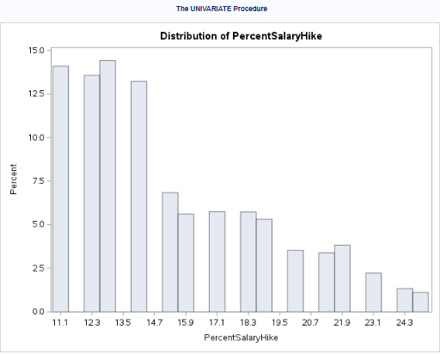
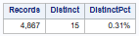

Table 2.2 fortune_acct - Categorical Data
Analytic categorical data fields
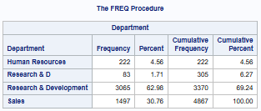 | 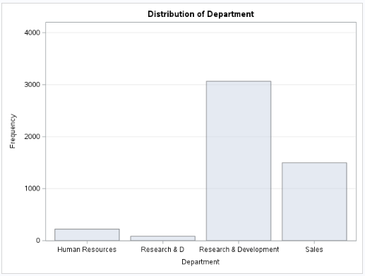
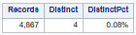
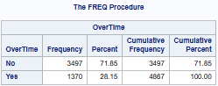 | 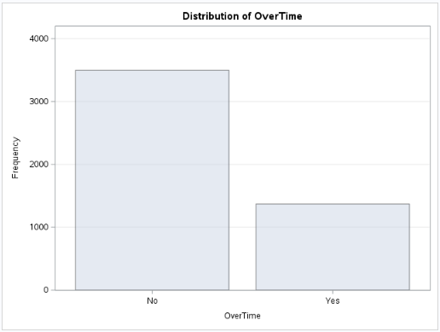
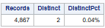

Table 2.2(cont.) fortune_acct - Categorical Data
Analytic categorical data fields
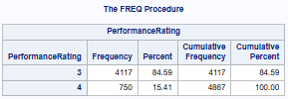 | 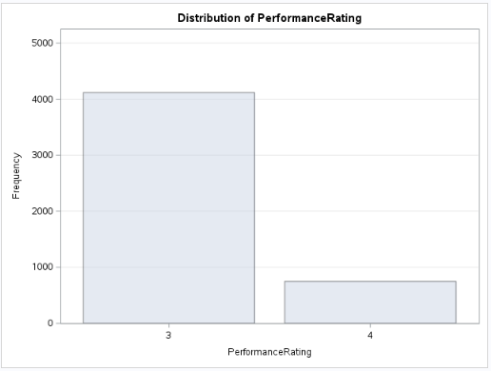
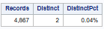
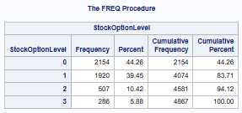 | 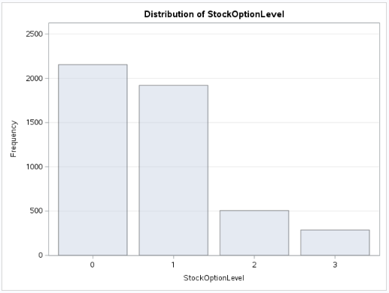
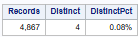

Table 2.3 fortune_acct - Character Data
Analytic character data fields
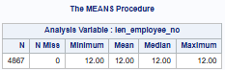 | 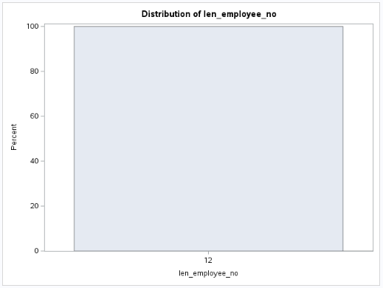
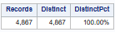

Table 2.3(cont.) fortune_acct - Character Data
Analytic character data fields
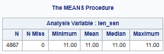 | 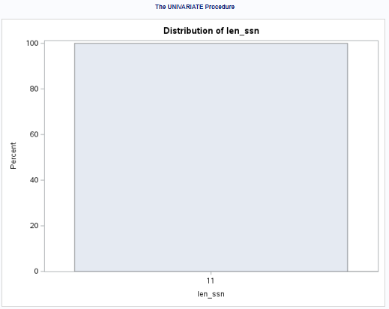
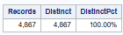

Datafile #3: fortune_attrition
File Analytic Contents:
Numeric Fields (0):
Categorical Fields (1): employee_no
Character Fields (0):
Date Fields (1): depart_dt
Records: 262
Columns: 2
Notes: The numeric categorical data field employee_no is likely a row id or index field, so it will be evaluated as Character Data.

Table 3.3 fortune_attrition - Character Data
Analytic character data fields
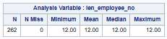 | 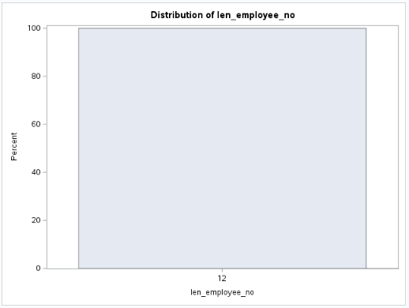
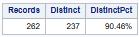

Table 3.4 fortune_attrition - Date Data
Analytic date data fields
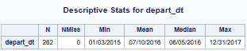 | 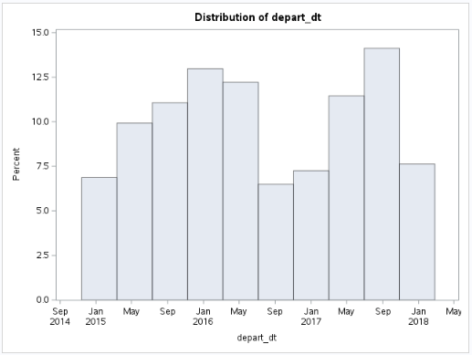
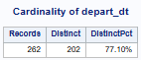

Datafile #4: fortune_hr
File Analytic Contents:
Numeric Fields (0):
Categorical Fields (5): Education, EducationField, Gender, birth_state, employee_no
Character Fields (1): first_name
Date Fields (2): birth_dt, hire_dt
Records: 4,867
Columns: 8
Notes: The numeric categorical data field employee_no is likely a row id or index field, so it will be evaluated as Character Data.

Table 4.2 fortune_hr - Categorical Data
Analytic categorical data fields
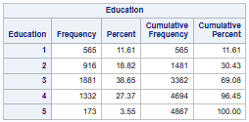 | 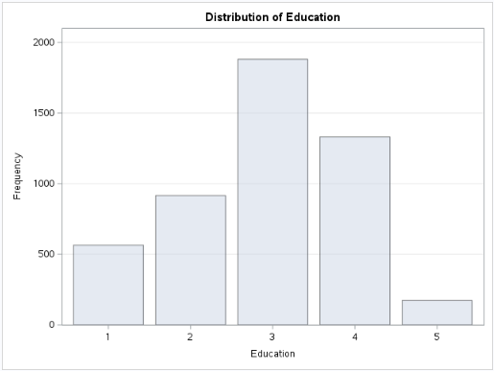
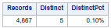

Table 4.2(cont.) fortune_hr - Categorical Data
Analytic categorical data fields
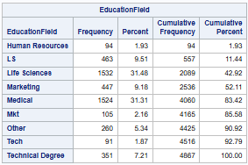 | 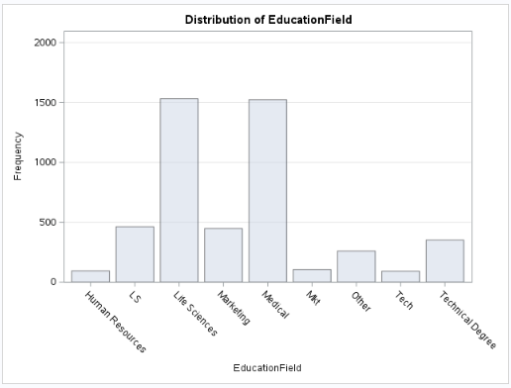
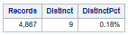
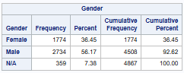 | 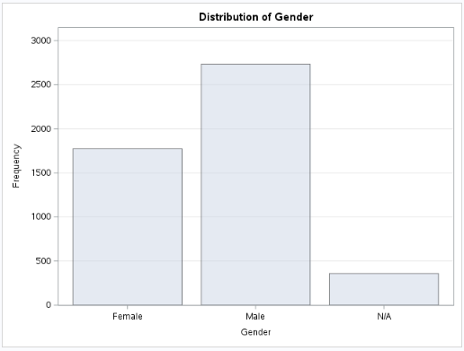
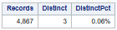

Table 4.2(cont.) fortune_hr - Categorical Data
Analytic categorical data fields
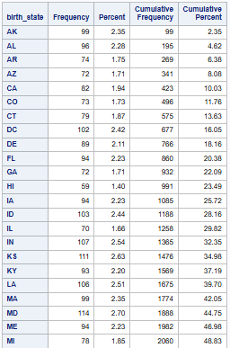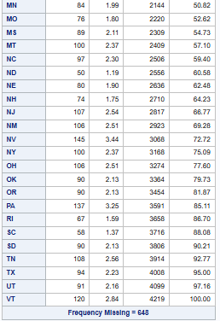
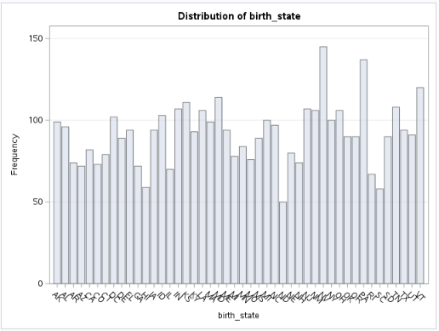
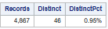

Table 4.3 fortune_hr - Character Data
Analytic character data fields
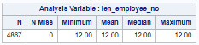 | 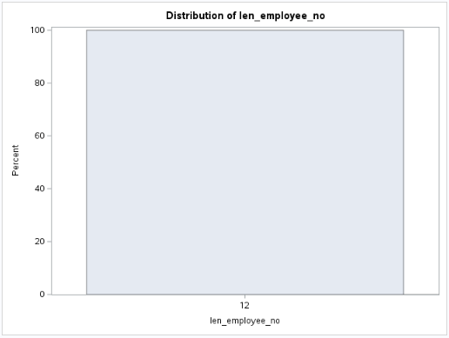
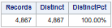
 | 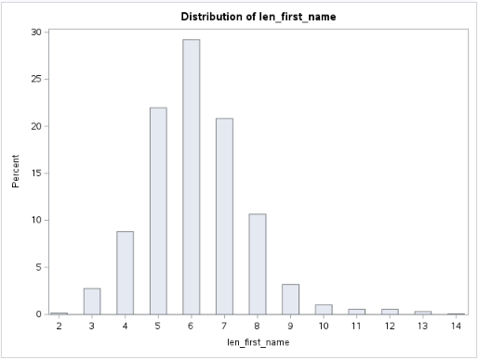
  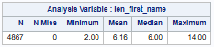
  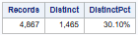

Table 4.4 fortune_hr - Date Data
Analytic date data fields
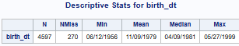 | 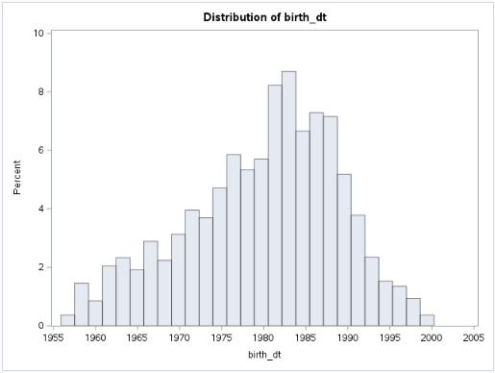
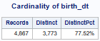

Table 4.4(cont.) fortune_hr - Date Data
Analytic date data fields
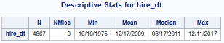 | 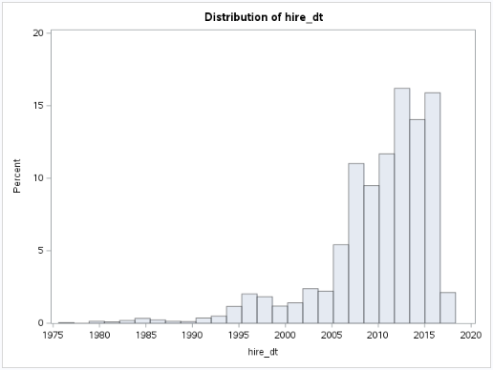
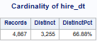

Datafile #5: fortune_survey
File Analytic Contents:
Numeric Fields (7): DistanceFromHome, NumCompaniesWorked,
TotalWorkingYears, TrainingTimesLastYear,
YearsInCurrentRole, YearsSinceLastPromotion,
YearsWithCurrManager
Categorical Fields (9): BusinessTravel, EnvironmentSatisfaction, JobInvolvement,
JobLevel, JobSatisfaction, MaritalStatus,
RelationshipSatifaction, WorkLifeBalance, employee_no
Character Fields (0):
Date Fields (0):
Records: 1,470
Columns: 16
Notes: The numeric categorical data field employee_no is likely a row id or index field, so it will be evaluated as Character Data.

Table 5.1 fortune_survey - Numeric Data
Analytic numeric data fields
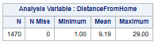 | 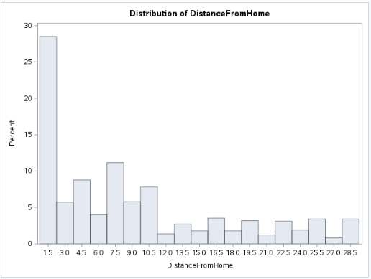
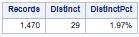

Table 5.1(cont.) fortune_survey - Numeric Data
Analytic numeric data fields
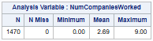 | 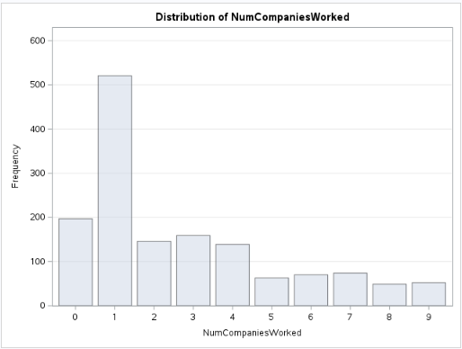
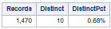
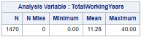 | 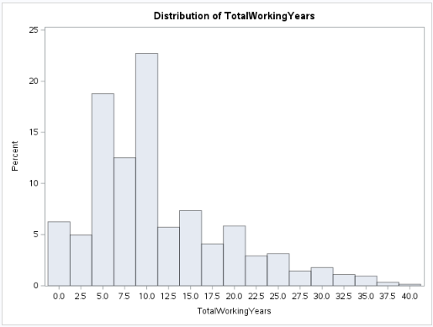
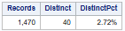
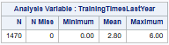 | 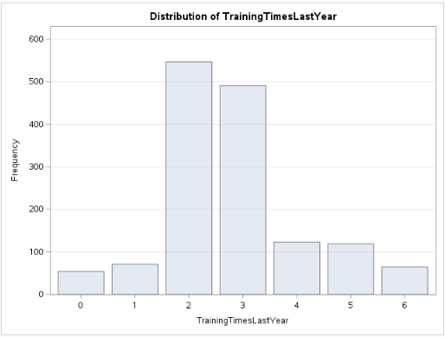
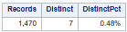

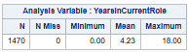 | 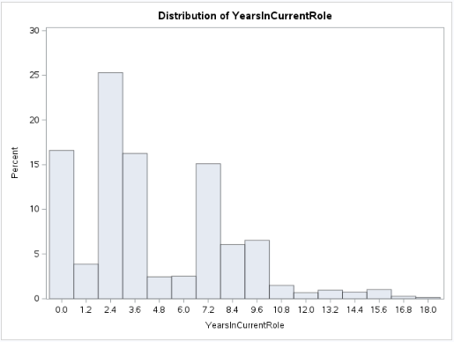
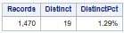

Table 5.1(cont.) fortune_survey - Numeric Data
Analytic numeric data fields
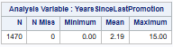 | 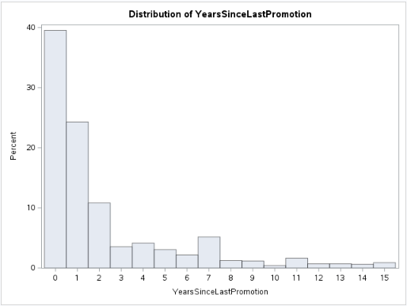
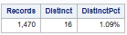
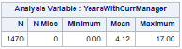 | 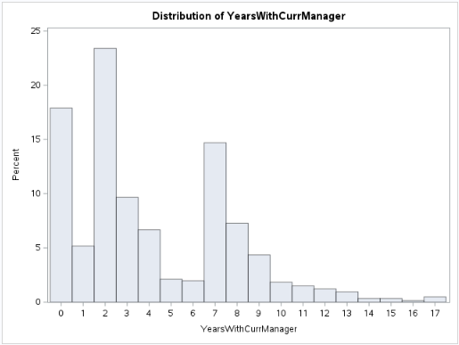
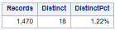

Table 5.2 fortune_survey - Categorical Data
Analytic categorical data fields
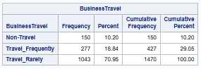 | 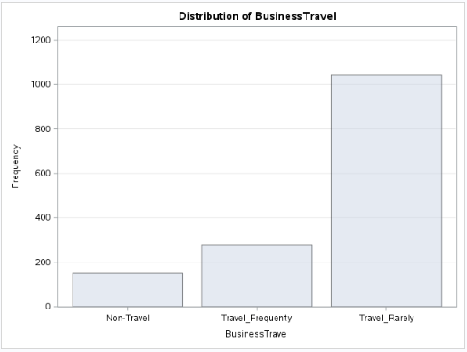
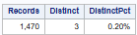

Table 5.2(cont.) fortune_survey - Categorical Data
Analytic categorical data fields
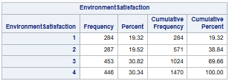 | 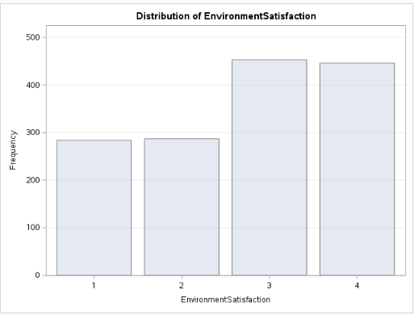
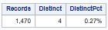
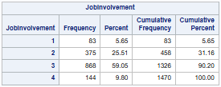 | 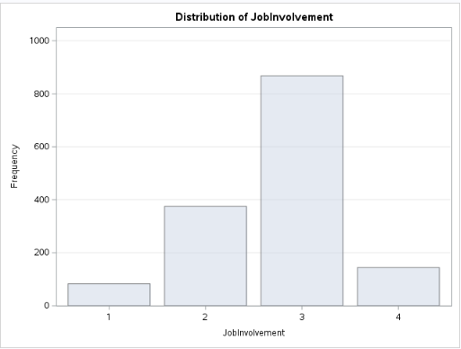
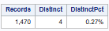

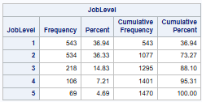 | 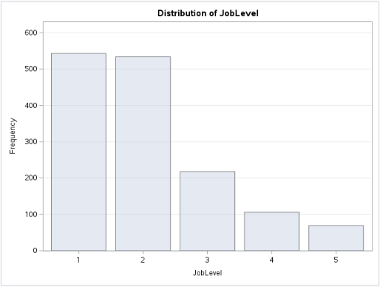
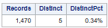

Table 5.2(cont.) fortune_survey - Categorical Data
Analytic categorical data fields
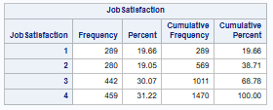 | 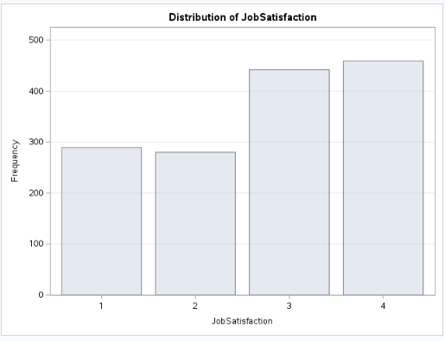
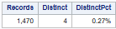
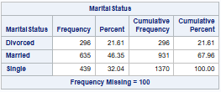 | 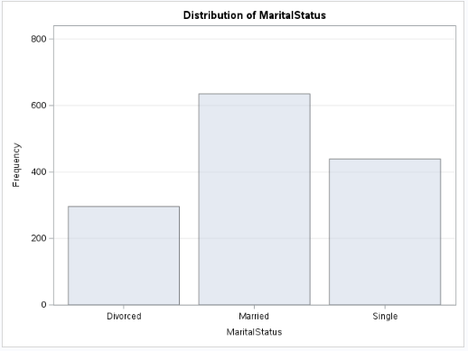
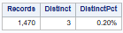

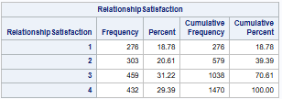 | 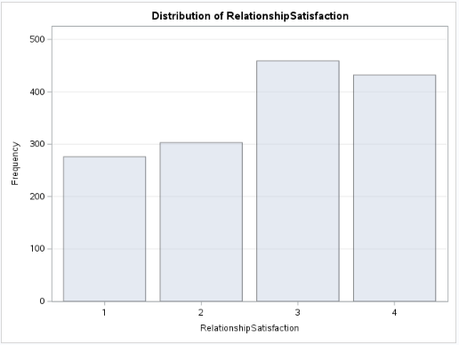
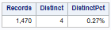

Table 5.2(cont.) fortune_survey - Categorical Data
Analytic categorical data fields
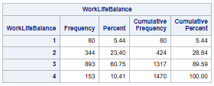 | 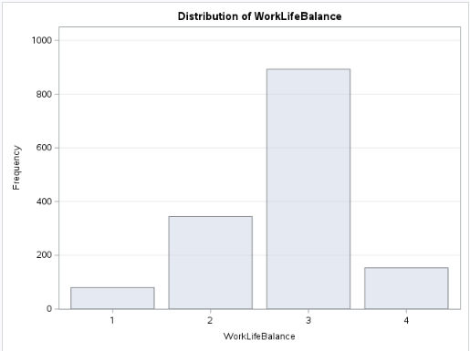
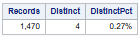

Table 5.3 fortune_survey - Character Data
Analytic character data fields
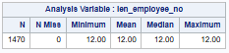 | 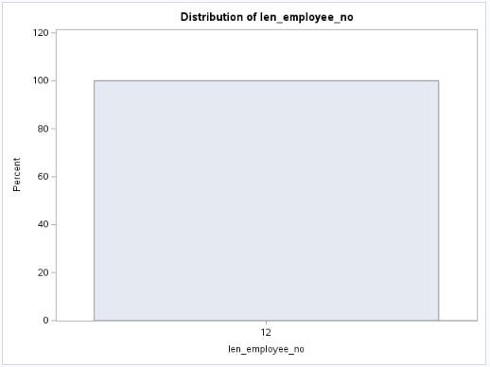
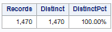

Modeling Sample

Segment | Count
Available event (yes) sample | 237
Available non-event (no) sample | 1,233
Total (target) sample | 1,470
Total records in datafile | 4,867

Sample sizes in the target segments appear to be of sufficient size to support a predictive model.
Questions

Does the above information appear to be correct? Specifically:

Does the lead data science team have all the data that was meant to be sent?

Is the team interpreting the data correctly?

Do the data appear to have reasonable values?

Here is a list of the data integrity issues the lead data science team uncovered. Please review:

The snn variable in the fortune_credit file is classified as numeric, but is classified as character in the fortune_acct file.

In the fortune_acct file, the DailyRate variable has 92 missing values (1.9%).

In the fortune_acct file, the MonthlyIncome variable has 92 missing values (1.9%).

In the fortune_acct file, the MonthlyIncome variable distribution has a significant right skew and some potentially extreme values.

In the fortune_acct file, the Department variable has two similar categorical values for Research & Development, with another called Research & D having 83 values (1.7%).

In the fortune_attrition file, the employee_no variable has 237 distinct values out of 262 records, suggesting duplicates of 25 values (9.5%). Record 14 and 15 were identified as duplicates.

In the fortune_hr file, the EducationField variable has two similar categorical values for Life Sciences, with another called L S having 463 values (9.5%).

In the fortune_hr file, the EducationField variable has two similar categorical values for Marketing, with another called Mkt having 105 values (2.2%).

In the fortune_hr file, the EducationField variable has two similar categorical values for Technical Degree, with another called Tech having 91 values (1.9%).

In the fortune_hr file, the Gender variable has 359 values of N/A (7.4%).

In the fortune_hr file, the birth_state variable has 648 missing values (13.3%).

In the fortune_hr file, the birth_dt variable has 270 missing values (5.5%).

In the fortune_hr file, the hire_dt variable has a significant left skew and some potentially extreme values that proceed the company start date of June 1980.

In the fortune_survey file, the NumCompaniesWorked variable has 197 values of 0 (13.4%).

In the fortune_survey file, the YearsInCurrentRole and YearsWithCurrManager variables have very similar distributions.

In the fortune_survey file, the MaritalStatus variable has 100 missing values (6.8%).

- The following are specific questions the lead data science team has about the data. Please review:

  - Concerning the fortune_acct file, the MonthlyIncome variable has some extremely high values (ex.. a 199,999.00 maximum). Are these values accurate?
  - Concerning the fortune_acct file, the PerformanceRating variable has only two recorded values, 3 and 4. Is there other potential values, or can these two be defined as something else?

In the fortune_survey file, the NumCompaniesWorked variable has 197 values of 0. Are the employees taking the survey including the job that they are currently working for, or were we interested in the number of companies worked prior to Fortune Corp?

Could human resources provide the lead data science team with a data dictionary to describe what the numeric categorical variable values (0,1,2,3,4,5,etc..) represent in the provided files?

